Sprint 3 Materials
Team 70

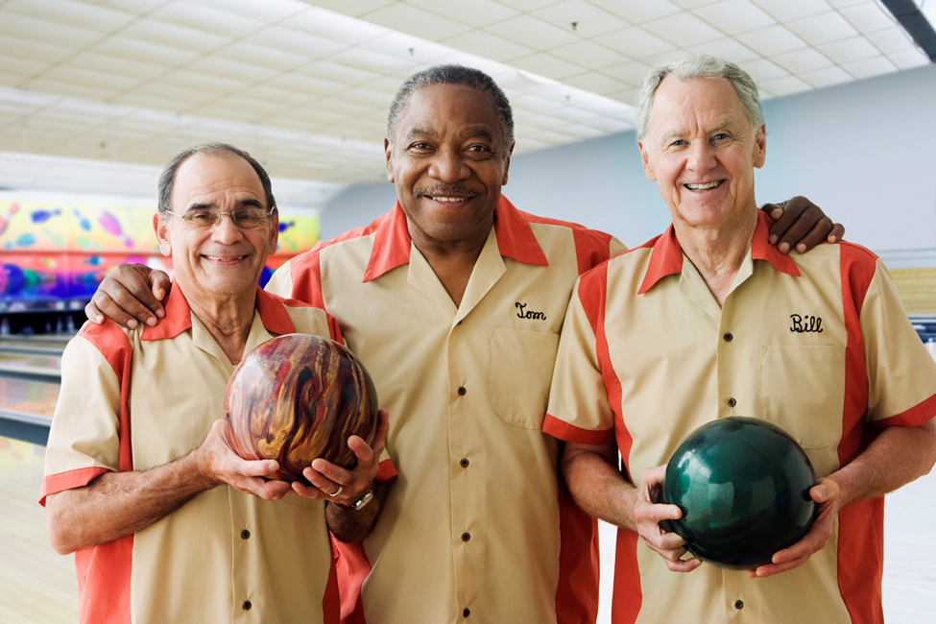
Grant Ashford
Brenden Barber
Leo Cuzela
Ryan Roeling
Sam Scarcelli
Jared Spotts

Retrospective Summary
Throughout Sprint 3, our sole focus was making sure we implemented all of our above and beyond features that were required, as well as finishing up multiple interfaces, which involved more attention to detail and production from each team member. One of the key things that went well for us throughout this sprint was communication and how we all kept in touch with one another on what tasks needed to be completed, ensuring that every team member was on the same page, such as with deadlines and expectations. The main thing that went wrong during this current sprint was the fact that the addition of new tasks needing to be completed sometimes broke other parts of our project and how that slowed the team down a bit, especially with testing and handling merge conflicts. Considering this was the last sprint for Project 3, for the procedural changes that should have been made, we understand the importance of task structure and how that could have been more beneficial to completing this sprint more efficiently, such as accommodating for how tasks were split up and distributed more effectively. The adjustments that were made to the product backlog within this sprint were adding and removing tasks that we found important or not important for this sprint, as we as a team were fine-tuning different features. Some backlog items were not met because of other tasks that we established to be more essential and crucial for what needed to be completed during this sprint.

GitHub Release Link
Github Release will be added here.

Product Backlog

Task | Sprint | Owner | Description | Priority | Dependencies | Story Points | Complete
1 | 1 | Leo | Set up project using React.js | 1 | 14 | 1 | O
2 | 1 | Grant | Update manager x-report | 2 | 3 | 1 | /
3 | 1 | Ryan | Update Manager Database interaction | 2 |  | 2 | /
4 | 1 | Brenden | Connect Kiosk View to database | 3 |  | 2 | O
5 | 1 | Leo | Configure Javascript/AWS Connectivity using ENV file | 3 |  | 2 | O
6 | 1 | Leo | Set up GitHub to Hosting platform integration | 1 |  | 1 | O
7 | 1 | Sam | Brainstorm thematic features | 4 |  | 1 | O
8 | 1 | Grant | Implement Kiosk UI | 3 |  | 3 | /
9 | 1 | Brenden | Implement thematic features for customer interface | 4 | 7,8 | 2 | O
10 | 1 | Brenden | Create branch strategies | 2 |  | 1 | O
11 | 1 | Jared | Write appropriate README | 5 |  | 1 | X
12 | 1 | Ryan | Add order status column to order table | 2 |  | 1 | O
13 | 1 | Jared | Update UML | 5 |  | 1 | X
14 | 1 | Leo | Set up Docker Environment | 1 |  | 2 | O
15 | 1 | Sam | Update Manager Documentation | 5 | 17 | 1 | X
16 | 1 | Sam | Create Kiosk Documentation | 5 | 9 | 1 | X
17 | 1 | Brenden | Perform Code Reviews for Manager | 4 | 2 | 1 | O
18 | 1 | Ryan | Seed database with test data | 2 | 12 | 1 | /
19 | 1 | Ryan  (Jared) | Connect Kitchen View to database | 3 |  | 1 | X
20 | 1 | Jared | Make kitchen display retrieve pending orders from database | 4 | 19 | 1 | X
21 | 1 | Brenden | Make kitchen display in progress orders | 4 | 12,20 | 1 | O
22 | 1 | Ryan | Make functionality to change order status | 5 | 21 | 2 | /
23 | 2 | Sam | Update login screen | 5 |  | 2 | O
24 | 2 | Sam | Test and Debug GUI | 5 | 8,25 | 3 | O
25 | 2 | Grant | Update user authentication UI | 5 | 8 | 3 | X
26 | 2 | Leo | Establish endpoints with weather | 1 |  | 2 | O
27 | 2 | Leo | Establish endpoints with translation | 1 |  | 2 | O
28 | 2 | Ryan | Establish endpoints with choice API | 1 |  | 2 | X
29 | 2 | Ryan | Integrate Google OAuth 2 for login | 2 | 25 | 2 | O
30 | 2 | Sam | Integrate Google Translate for kiosk | 2 | 27 | 2 | O
31 | 2 | Leo | Integrate OpenWeather API for weather display | 2 | 26 | 2 | O
32 | 2 | Jared | Choose an API | 1 |  | 1 | O
33 | 2 | Grant | Implement screen reader support | 4 | 8 | 2 | X
34 | 2 | Sam | Add color contrast | 4 | 8 | 1 | O
35 | 2 | Sam | Add scalable text | 4 | 8 | 2 | O
36 | 2 | Brenden | Document issues for task tracking | 2 |  | 1 | X
37 | 2 | Ryan | Adapt cashier GUI | 1 |  | 1 | O
38 | 2 | Ryan | Add accessibility option (interface) | 3 | 8 | 2 | O
39 | 2 | Jared | Make dynamic menu | 4 |  | 3 | X
40 | 2 | Jared | Make multi-display feature | 4 |  | 3 | X
41 | 2 | Grant | Create Menu Documentation | 5 | 40 | 1 | X
42 | 2 | Brenden | Implement new login validation logic | 2 | 25 | 2 | O
43 | 2 | Leo | Perform Code Reviews for kiosk | 5 | 30 | 2 | O
44 | 2 | Jared | Integrate chosen API | 2 | 32 | 3 | X
45 | 3 | Ryan | Connect Menu board to database | 4 |  | 1 | O
46 | 3 | Leo | Audit for WCAD 2.1 compliance | 5 | 38 | 2 | O
47 | 3 | Grant | Add payment screen | 1 | 43 | 2 | O
48 | 3 | Jared | Integrate dynamic menus into multi-display | 1 | 39,40 | 3 | O
49 | 3 | Grant | Create Kitchen Documentation | 4 | 21 | 1 | X
50 | 3 | Jared | Perform Code Reviews for Kitchen | 5 | 50 | 2 | O
51 | 3 | Brenden | Perform Code Reviews for Menu Board | 5 | 49 | 2 | O
52 | 3 | Grant | Fix text to speech | 1 | 33 | 2 | O
53 | 3 | Ryan | Implement the receipt feature | 4 | 48 | 1 | O
54 | 3 | Sam | Implement allergy warnings | 2 | 48 | 3 | O
55 | 3 | Sam | Implement a drop down menu for drinks, allergies, and categories | 5 | 48 | 2 | O
56 | 3 | Jared | Implement the QR code feature | 3 | 48, 55 | 1 | O
57 | 3 | Jared | Make a button to demo the weather drink recommendations. | 2 | 49 | 1 | O
58 | 3 | Jared | Implement the rest of the manager view | 3 |  | 8 | O
59 | 3 | Grant | Fix the index page | 3 |  | 1 | O
60 | 3 | Ryan | Implement Tax | 4 |  | 3 | O
61 | 3 | Ryan | Test live deployment | 5 | everything | 3 | O
Sprint Backlog

45 | 3 | Ryan | Connect Menu board to database | 4 |  | 1 | O
46 | 3 | Leo | Audit for WCAG 2.1 compliance | 5 | 38 | 3 | O
47 | 3 | Grant | Add payment screen | 1 | 43 | 2 | O
48 | 3 | Brenden | Integrate dynamic menus into multi-display | 1 | 39,40 | 3 | O
49 | 3 | Grant | Create Kitchen Documentation | 4 | 21 | 1 | X
50 | 3 | Jared | Perform Code Reviews for Kitchen | 5 | 50 | 2 | O
51 | 3 | Brenden | Perform Code Reviews for Menu Board | 5 | 49 | 2 | O
52 | 3 | Grant | Fix text to speech | 1 | 33 | 2 | O
53 | 3 | Ryan | Implement the receipt feature | 4 | 48 | 2 | O
54 | 3 | Sam | Implement allergy warnings | 2 | 48 | 3 | O
55 | 3 | Sam | Implement a drop down menu for drinks, allergies, and categories | 5 | 48 | 2 | O
56 | 3 | Ryan | Implement the QR code feature | 3 | 48, 55 | 1 | O
57 | 3 | Jared | Make a button to demo the weather drink recommendations. | 2 | 49 | 1 | O
58 | 3 | Jared | Implement the rest of the manager view | 3 |  | 8 | O
59 | 3 | Grant | Fix the index page | 3 |  | 1 | O
60 | 3 | Ryan | Implement Tax | 4 |  | 3 | O
61 | 3 | Ryan | Test live deployment | 5 | everything | 3 | O

NAME: | Leo | Jared | Grant | Sam | Brenden | Ryan
SPRINT 3 POINTS: | 3 | 11 | 5 | 5 | 5 | 10

Burn-down Charts

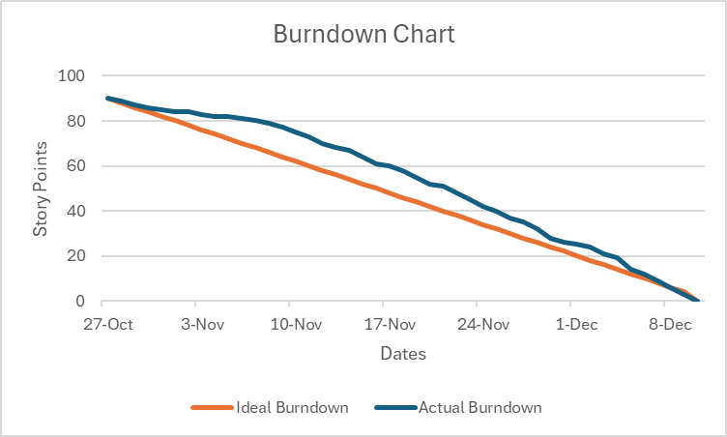
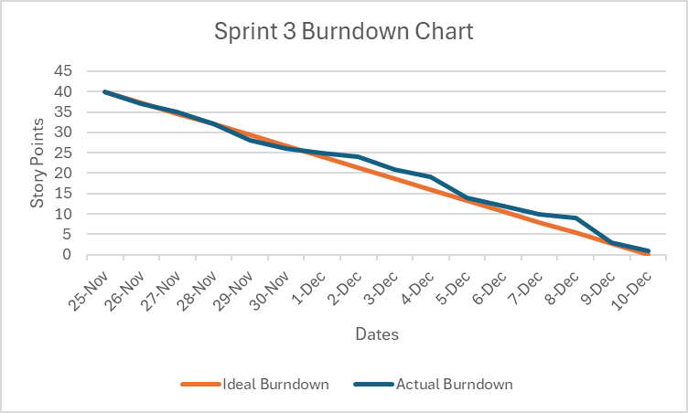

Sprint Test Plan
The following points summarize our Sprint 3 testing approach:
- Testing in Sprint 3 focused on verifying that each completed Sprint 3 backlog item met its defined acceptance criteria.
- Acceptance criteria was formed by taking into account
  - Accessibility
  - User personas
  - User experience
  - Functionality
- After each merge into the main branch, team members tested the updated Vercel deployment to validate Sprint 3 changes.
- This process allowed the team to identify and resolve issues, especially within the kiosk, which contained the highest number of interconnected features and required the most thorough verification.
Below are completed Sprint 3 tasks and their regression testing acceptance criteria:

- Connect Menu Board to Database
  - Ensure that menu items are from the database.
  - Ensure that any updates on the database show up on the menu board.
- Integrate dynamic menus into multi-display
  - Ensure the highlighted drink recommendations make sense.
  - Ensure the highlighted drinks change with time and temperature.
- Implement allergy warnings
  - Ensure that menu items show the right allergens.
  - Ensure warnings display for allergens.
- Implement a drop-down menu for drinks, allergies, and categories
  - Ensure that each allergy option is displayed correctly.
  - Ensure that that sweetness, temperature, and ice level can be changed.
- Implement the QR code feature
  - Ensure that the QR codes are generated correctly.
  - Ensure that each QR code link is valid.
- Implement the rest of the manager view
  - Ensure that inventory updates correctly.
  - Ensure that restock updates the inventory correctly.
  - Ensure that menu items can be added and removed.
  - Ensure that you can select ingredients and their amounts when adding a menu item.
  - Ensure that both the x-report and z-report are precise.
- Fix the index page
  - Ensure that the home page is more visually appealing.
  - Ensure that the home page allows for each interface to be linked to.
- Fix text to speech
  - Ensure that the process of an order on kiosk works with the narration feature.
- Implement the receipt feature
  - Ensure that it is formatted correctly.
  - Ensure that the totals are correct.
- Make a button to demo the weather drink recommendations
  - Ensure that the drink recommendations are updated regularly.
- Auditing for WCAG 2.1 compliance
  - Ensure that we are compliant with our accessibility features.
- Implement Tax
  - Ensure that each tax calculation for a menu item is correct.
- Test live deployment
  - Ensure that all of our features work as intended.

Next Sprint’s SCRUM Meeting Schedule
There are no planned scrum meetings for the next sprint, considering this was our last sprint for Project 3.
Appendix 1: SCRUM Meeting Agendas and Minutes

SCRUM Meeting 7 for Project 3
Prepared by: Leo Cuzela
Meeting Date: 12/1

Meeting Attendees
- Grant Ashford
- Leo Cuzela
- Brenden Barber
- Ryan Roeling
- Sam Scarcelli
- Jared Spotts

Meeting Agenda Items
- Discuss the different types of features that need to be implemented in the kiosk.

Status Update Since Last Meeting
Accomplishments:
- Ensured that Google OAuth was able to sign users into different views based on role.
- Ensured that the payment screen was implemented with basic functionality with features being added at another time.

Tasks Completed:
Task Description | Assigned to | Completed? (yes/no)
Make Google OAuth sign users into different views based on role | Ryan | Yes
Add a payment screen | Grant | Yes

Before The Next Meeting
Plans:
- Strive to have the text to speech feature be fully functional with other languages.
- Begin implementing the receipt feature within the kiosk.

Task Assignments:
Task Description | Assigned to
Fix text to speech to fully work with other languages | Grant
Implement the receipt feature | Ryan

Minutes from Previous Meeting
We discussed as a team the importance of adding the different types of key features to the kiosk. Also, we talked about the significance of the week ahead and our performance as a group knowing that the project has to be fully functional next week.

SCRUM Meeting 8 for Project 3
Prepared by: Leo Cuzela
Meeting Date: 12/3

Meeting Attendees
- Grant Ashford
- Leo Cuzela
- Brenden Barber
- Ryan Roeling
- Sam Scarcelli
- Jared Spotts

Meeting Agenda Items
- Discuss the importance of the implementation of adding allergies to the kiosk.

Status Update Since Last Meeting
Accomplishments:
- The text to speech implemented within the kiosk works with some languages.
- Progress has been made on the implementation of the receipt feature within the kiosk.

Tasks Completed:
Task Description | Assigned to | Completed? (yes/no)
Fix text to speech to fully work with other languages | Grant | No
Implement the receipt feature | Ryan | No

Before The Next Meeting
Plans:
- Implement allergy warnings
  - Add more allergies to the ingredients
  - Drinks displayed filter out the allergies.
- Ensure that adding drinks, allergies, and categories should be selectable from drop down menus.
Task Assignments:
Task Description | Assigned to
Implement allergy warnings | Brenden/Sam
Implement a drop down menu for drinks, allergies, and categories (Examples: Ice and Sweetness Level) | Sam

Minutes from Previous Meeting
We talked about the importance of who is doing what task, so we do not cause confusion with one another with the deadline approaching. Additionally, we discussed what type of progress needed to be made for the text to speech functionality and the implementation of payment screen.
SCRUM Meeting 9 for Project 3
Prepared by: Leo Cuzela
Meeting Date: 12/5

Meeting Attendees
- Grant Ashford
- Leo Cuzela
- Brenden Barber
- Ryan Roeling
- Sam Scarcelli
- Jared Spotts

Meeting Agenda Items
- Discuss about the assignments due on Monday and the preparation for them.
- Discuss our progress on the implementation of the menu board.

Status Update Since Last Meeting
Accomplishments:
- The allergy feature was implemented and is functional.
- The drop down menu for drinks, allergies, and categories was implemented and is functional.

Tasks Completed:
Task Description | Assigned to | Completed? (yes/no)
Implement allergy warnings | Brenden/Sam | Yes
Implement a drop down menu for drinks, allergies, and categories (Examples: Ice and Sweetness Level) | Sam | Yes

Before The Next Meeting
Plans:
- There will not be a next meeting. Meeting 9 was our last SCRUM meeting.

Task Assignments:
Task Description | Assigned to
Implement the QR code feature (Along with fully implementing the receipt feature) | Jared
Provide the user a button that will send them an email of their receipt | Jared
Implement the rest of the manager view. | Jared
Fix the index page | Grant
Implement the rest of the menu board | Leo/Ryan
Test live deployment | Ryan

Minutes from Previous Meeting
A discussion was had about how implementing the allergies feature would be important for the kiosk because it is one of our above and beyond features. Also, we talked about the significance of what we had left with our above and beyond features.
Include additional SCRUM Agendas and Minutes on new pages if necessary (if you have more than 3 SCRUM meetings in a sprint).

